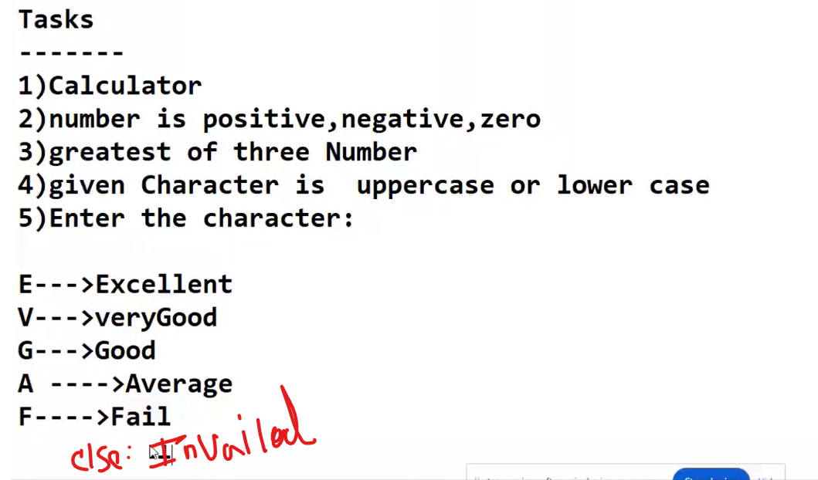

# calculator  
  
num1 = int(input("Enter the first number: "))  
num2 = int(input("Enter the second number: "))  
  
print("if you want to sum type 1")  
print("if you want to subtract type 2")  
print("if you want to multiply type 3")  
print("if you want to divide type 4")  
print("if you want to modulo type 5")  
print("if you want to floor division type 6")  
print("if you want to exponent type 7")  
  
#print("if you want to break type 0")  
while(1==1):  
  
 operators = int(input())  
  
 if operators == 1:  
 print(num1, "+", num2, "=", num1 + num2)  
 print("if you want to break type 0")  
 elif operators == 2:  
 print(num1, "-", num2, "=", num1 - num2)  
 print("if you want to break type 0")  
 elif operators == 3:  
 print(num1, "*", num2, "=", num1 * num2)  
 print("if you want to break type 0")  
 elif operators == 4:  
 print(num1, "/", num2, "=", num1 / num2)  
 print("if you want to break type 0")  
 elif operators == 5:  
 print(num1, "%", num2, "=", num1 % num2)  
 print("if you want to break type 0")  
 elif operators == 6:  
 print(num1, "//", num2, "=", num1 // num2)  
 print("if you want to break type 0")  
 elif operators == 7:  
 print(num1, "**", num2, "=", num1 ** num2)  
 print("if you want to break type 0")  
 elif operators == 0:  
 break  
  
 else:  
 print("Error invalid numbers or function")

Enter the first number: 200

Enter the second number: 5

if you want to sum type 1

if you want to subtract type 2

if you want to multiply type 3

if you want to divide type 4

if you want to modulo type 5

if you want to floor division type 6

if you want to exponent type 7

1

200 + 5 = 205

if you want to break type 0

2

200 - 5 = 195

if you want to break type 0

3

200 * 5 = 1000

if you want to break type 0

4

200 / 5 = 40.0

if you want to break type 0

5

200 % 5 = 0

if you want to break type 0

6

200 // 5 = 40

if you want to break type 0

7

200 ** 5 = 320000000000

if you want to break type 0

0

Process finished with exit code 0

# The number is positive or negative or zero  
  
num = int(input("Enter your number: "))  
  
if num > 0:  
 print(num,"is positive number")  
  
elif num == 0:  
 print(num,"is zero")  
  
else:  
 print(num,"is Negative number.")

Enter your number: 50

50 is positive number

#which is largest of three numbers  
  
num1 = int(input("Enter the number 1 :"))  
num2 = int(input("Enter the number 2 :"))  
num3 = int(input("Enter the number 3 :"))  
  
if (num1 > num2 and num1 > num3):  
 print(num1,"is largest number")  
elif(num2 > num3):  
 print(num2,"is largest number")  
else:  
 print(num3,"is largest number")

Enter the number 1 :20

Enter the number 2 :30

Enter the number 3 :5

30 is largest number

# Given character is uppercase OR lowercase  
  
letter=input("Enter the letter :")  
  
if(letter>='a' and letter<='z'):  
 print("This character is lower case")  
elif(letter>='A' and letter<='Z'):  
 print("This character is upper case")  
else:  
 print("Invalid character")

Enter the letter :h

This character is lower case

letter=input("Enter the letter :")  
  
if(letter=='e' or letter=='E'):  
 print("Excellent")  
elif(letter=='v' or letter=='V'):  
 print("Very Good")  
elif(letter=='g' or letter=='G'):  
 print("Good")  
elif(letter=='a' or letter=='A'):  
 print("Average")  
elif(letter=='f' or letter=='F'):  
 print("Fail")  
  
else:  
 print("Invalid character")

Enter the letter :e

Excellent